ECA0303-SIGNALS AND SYSTEM
NAME : BHARATH A
REG NO : 192512384
Experiment 1.1
Generation of Continuous Time Signals
Program:
% Generation of Continuous Time Signals
clc;
clear;
close all;
% Time axis
t = -5:0.01:5;
% Continuous-time sine signal
x = sin(2*pi*t);
% Plotting
figure;
plot(t, x, 'LineWidth', 2);
grid on;
title('Continuous Time Sine Signal');
xlabel('Time (seconds)');
ylabel('Amplitude');

Expected Output:
A continuous-time sine wave is displayed with:
• Time range: -5 s to 5 s
• Amplitude range: -1 to 1
• Periodic sinusoidal waveform
Output Waveform:
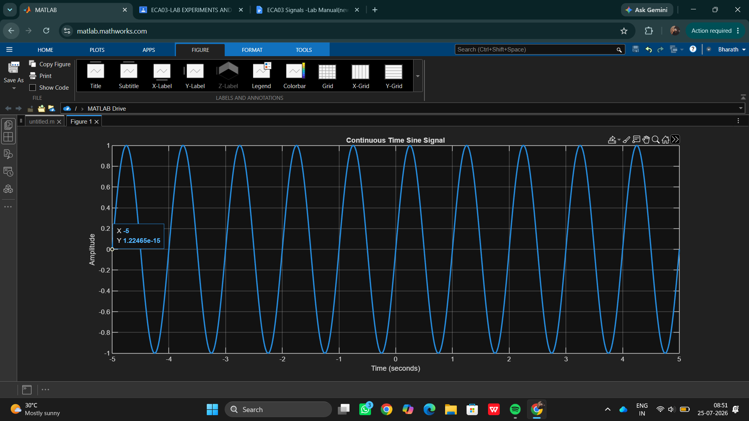

Result:
This test case validates that the signal generator can produce a sinusoidal waveform with the specified frequency, amplitude, and phase shift.

